Rig Board Feedback – 2018/01/05

# Show Stoppers

1. Certain jobs are not showing up with the correct times; I think the are keeping on Location time form the previous job. – by Craig

Analysis: The example Craig gave was the #1078312 created by Colin by mistake, since the call sheet stays in In-Progress status, so it will always be the next available job on the Board.

Solution: Add “Canceled” and “Deleted” status for Call Sheet and Rig Job, this will make them invisible from showing on board.

1. Deactivated rigs still shows on the board.

Analysis: Dispatcher wants the deactivated rigs hidden from the board instead of showing at bottom.

Solution: Archive the Rig Jobs if a rig is deactivated. Create separate “Activate a Rig” interface for re-activate a rig. Remove the “Activate” menu from Rig pop up menu

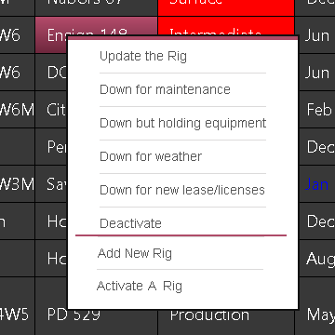

1. Allow Project Rig separate from regular rigs

Analysis: We do have the situation that a dedicated dispatcher working on project rigs only, we need to be able to filter out the Project Rigs from other regular rigs.

Solution: Enhance rig table to add a flag “Is_Project_Rig”, this flag should be carried over to rig job. On Rig Board, add a check box “Project Rig”, when it is checked, display rig jobs on Project Rigs, otherwise display rig jobs not on Project Rigs.

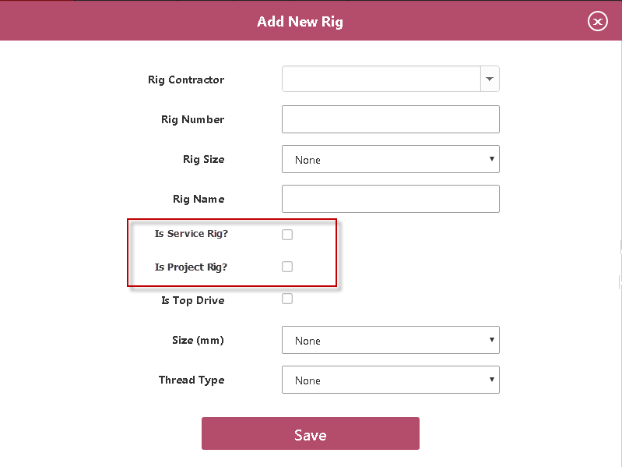

# Bug

1. When Job Package is sent to server, rig job is not updated as “Completed”.

Reason: Rig Job status update logic is not in UpdateJob method, but this won’t happen until the Update Job is hit.

Solution: Move the Rig Job status update logic to CreateJob method, when the job is created, the related rig job status needs to be updated

1. Job Status Color Coding is not set properly——BUG #095

Solution: Craig will propose a set of color code

1. When a rig job is in “Completed” status, some job specific functions should be disabled.

Solution: Disable the pop up menu for ——BUG #096

* Blends
* Well Location

1. Time is not displayed correctly when rig job is scheduled. ——BUG #097

When is rig job is scheduled, the rig job time should display the new requested time in Call out section.

Additional information:

1. When create a new call sheet, “First Call -> Expected Time On Location” is check. The call sheet status is in progress. At this time, the Date for this job should display as the time in “First Call -> Expected Time On Location”. Now it display blank. This may happens only the first time call sheet is created. Later it works ok during updating call sheet.

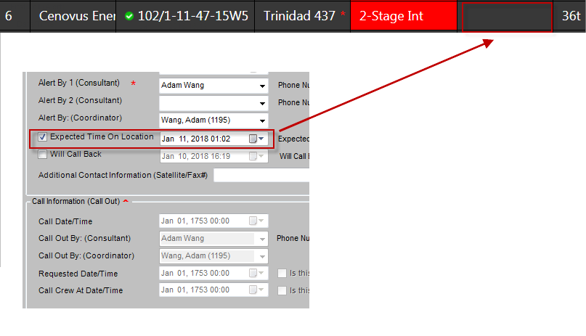

1. When uncheck “, “First Call -> Expected Time On Location”, Call Information section is enabled, the time in “First Call -> Expected Time On Location” should be copied to “Call Information-> Requested Date/Time” box. Now if fills in the time of clicking

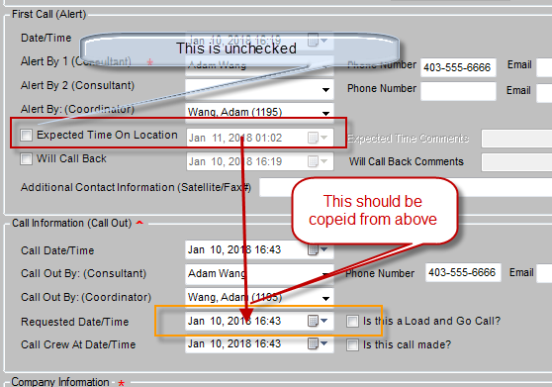

1. When I save a call sheet, the associated rig job disappear from Rig Board. After I dig into code, I found the problem in CallSheetService

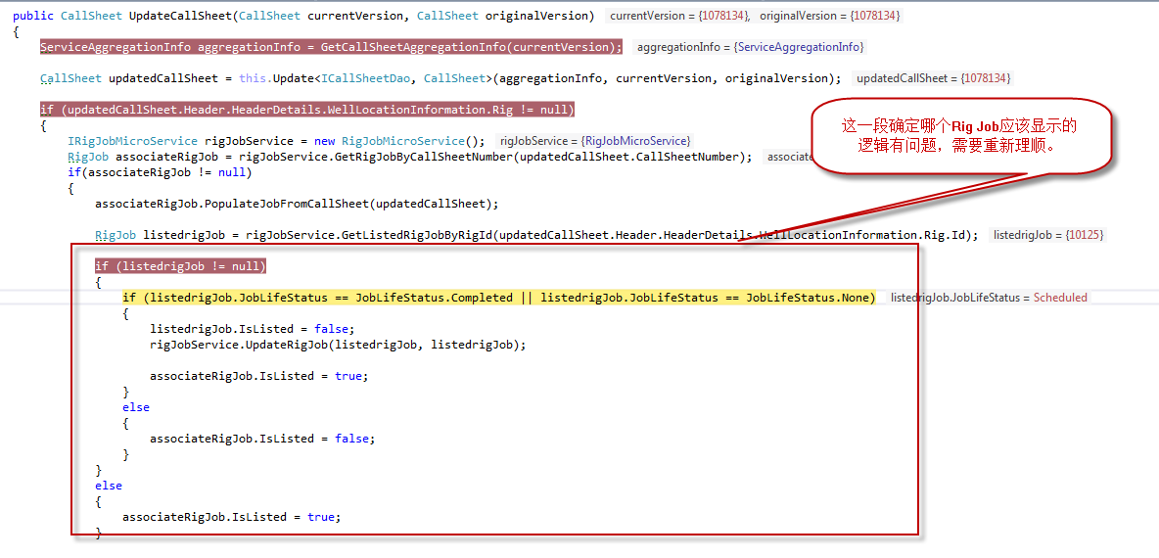

1. Call Out function didn’t timestamp properly——BUG #098

In Rig Board, when click “Call Out”

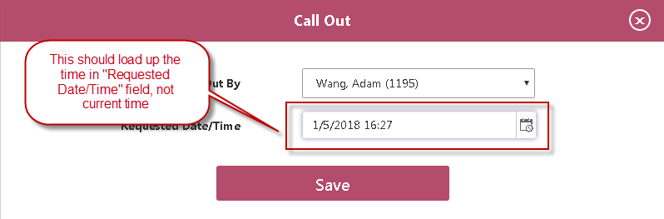

When Save button is clicked, the new “Requested Date/Time” in call sheet is updated if it is changed.

“Call Crew At Date/Time” should be updated as current time, “Is this call made?” is checked.

# Enhancements

1. Product Haul Enhancement
   1. Add one more Unit dropdown list to product haul page, make them aligned with Primary Unit and Tractor Unit.
   2. Add default comments in Unit Section Description, like “Haul 36t Thermal 40 on Jan 01,2017 to Bin 1234”
   3. Write comments entered by user in product haul page in Unit Section Description, right after default comments.

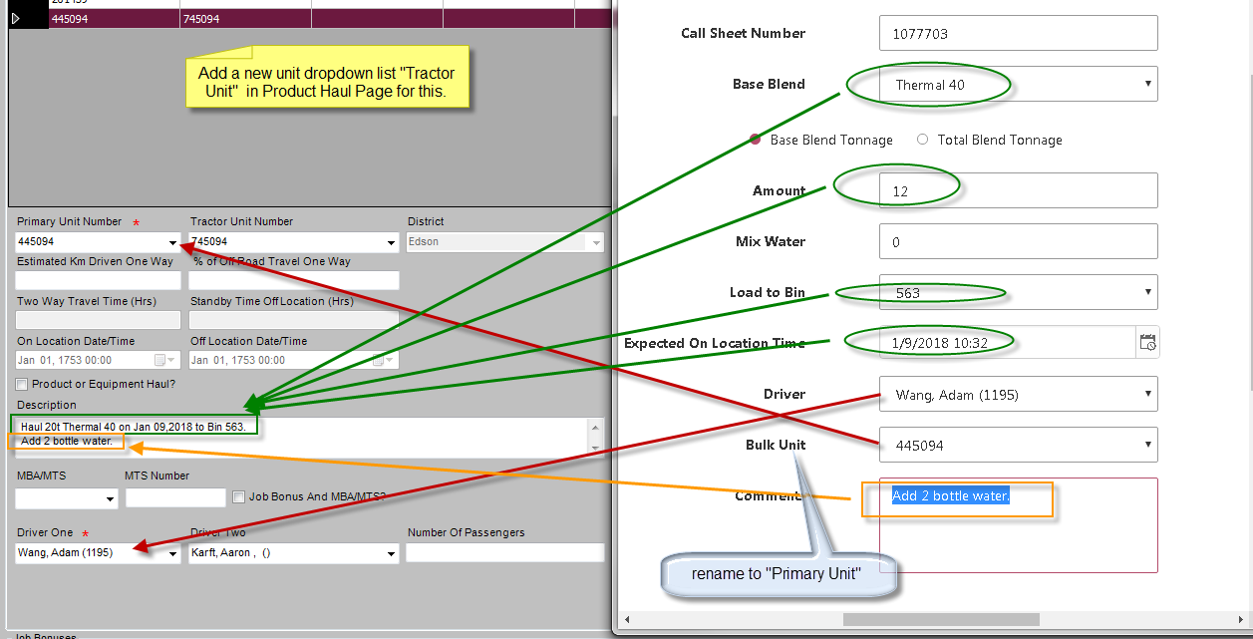

1. Third party Product Haul Enhancement

Sometimes we use third party truck to haul product. We need a check box in product haul page to allow choosing third party units.

When check the Third Party checkbox, the unit and driver party will show following items:

Supplier Company List – dropdown list

Third Party Unit Number – text box

Supplier Contact Name – text box

Supplier Contact Number – text box

After the product haul is scheduled, one record will be inserted to Third Party Units section in Call Sheet.

1. Archive historical rig jobs

As time going, the completed rig jobs will accumulate to slow down the performance. And it may bring in the complexity to determine which one should be displayed on the board. However, we need to keep them for reporting and auditing purposes.

Solution: Daily database script to perform the archiving job task, archive_rig_job table has same structure as rig_job table, keep the original id from rig_job

What jobs need to be archived.

1. Jobs on inactive rigs. Normally happens after the rig is deactivated, all associated rig jobs will be moved to archive_rig_job table.
2. Completed/Canceled Jobs before second last listed job. Since the current on-going rig job can be deleted, it will unlisted from the board, if there are no upcoming jobs, the previous listed job should be relisted to maintain the active rig displayed on the board.

Completed and Canceled job are normal and treated in same way.

If the listed job is canceled, and there is no up-coming job, the canceled job is still listed.

If the listed job is canceled, and there is an upcoming job, the upcoming job will be listed.

If the listed job is deleted, and there is no up-coming job, the previous listed job will be re-listed.

If the listed job is deleted, and there is an upcoming job, the upcoming job will be listed.

Feedback 180111

1. Colour Scheme: - Don’t need to make changes, Adam made the change.

* Alerted – Same Colour as Pending
* Pending – need a darker red. **We use R: 255 G: 0 B: 0**
* Confirmed – Stay the same
* Dispatched – Change Background of just the time cell to black, like so:



In Progress - No change in colour between dispatched and in progress

1. Bug: There are some duplicated rigs newly created. If may be caused by clicking Save button twice when creating a new rig. A validation is needed to avoid the duplication during creating new rig. The combination of Drilling Company Id and Rig No must be unique.—— BUG #099
2. Hide blend numbers after the Rig Job is Complete. —— BUG #100

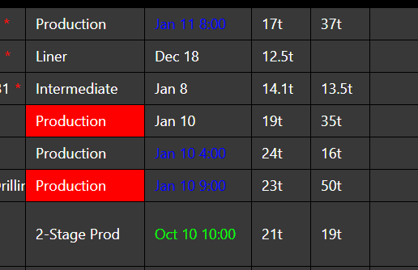

1. Bug: No rig job should be listed after the rig is deactivated. —— BUG #101